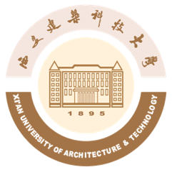
中国·陕西·西安雁塔路中段13号
西安建筑科技大学研究生院
The Graduate School of
Xi'an University of Architecture and Technology
No. 13 Yanta Road, Xi’an
Shaanxi Province, P. R. China, 710055
Tel: +86-29-82201294, Fax:+86-29-82201294

证 明

兹证明**，男，生于****年*月*日，学号：*******。于****年*月进入西安建筑科技大学学习，现系**学院**专业硕士研究生，学制三年。
特此证明

西安建筑科技大学
研究生院
****年*月*日

The Graduate School of
Xi'an University of Architecture and Technology
No. 13 Yanta Road, Xi’an
Shaanxi Province, P. R. China, 710055
Tel: +86-29-82201294, Fax:+86-29-82201294

January 10th, 2015
CERTIFICATION
This is to certify that Li Ming, male, born on Feb. 26th of 1992, student No. 20070809, enrolled in Xi'an University of Architecture and Technology in Sept. of 2012，is a full-time postgraduate in the three-year-program, who is majored in Landscape Design at the College of Architecture.

The Graduate School of
Xi'an University of Architecture and Technology

